| Course Name | ITD 2343 – Object Oriented Programming with C# |
| --- | --- |
| Instructor | Mark L. Pranger |
| Student Name | <Ezequiel Barrientos> |
| Due date | <11/11/25> |
| Grade | <grade earned here> |
| Grading Comments | <instructor comments here> |

Test Run 1 : Addition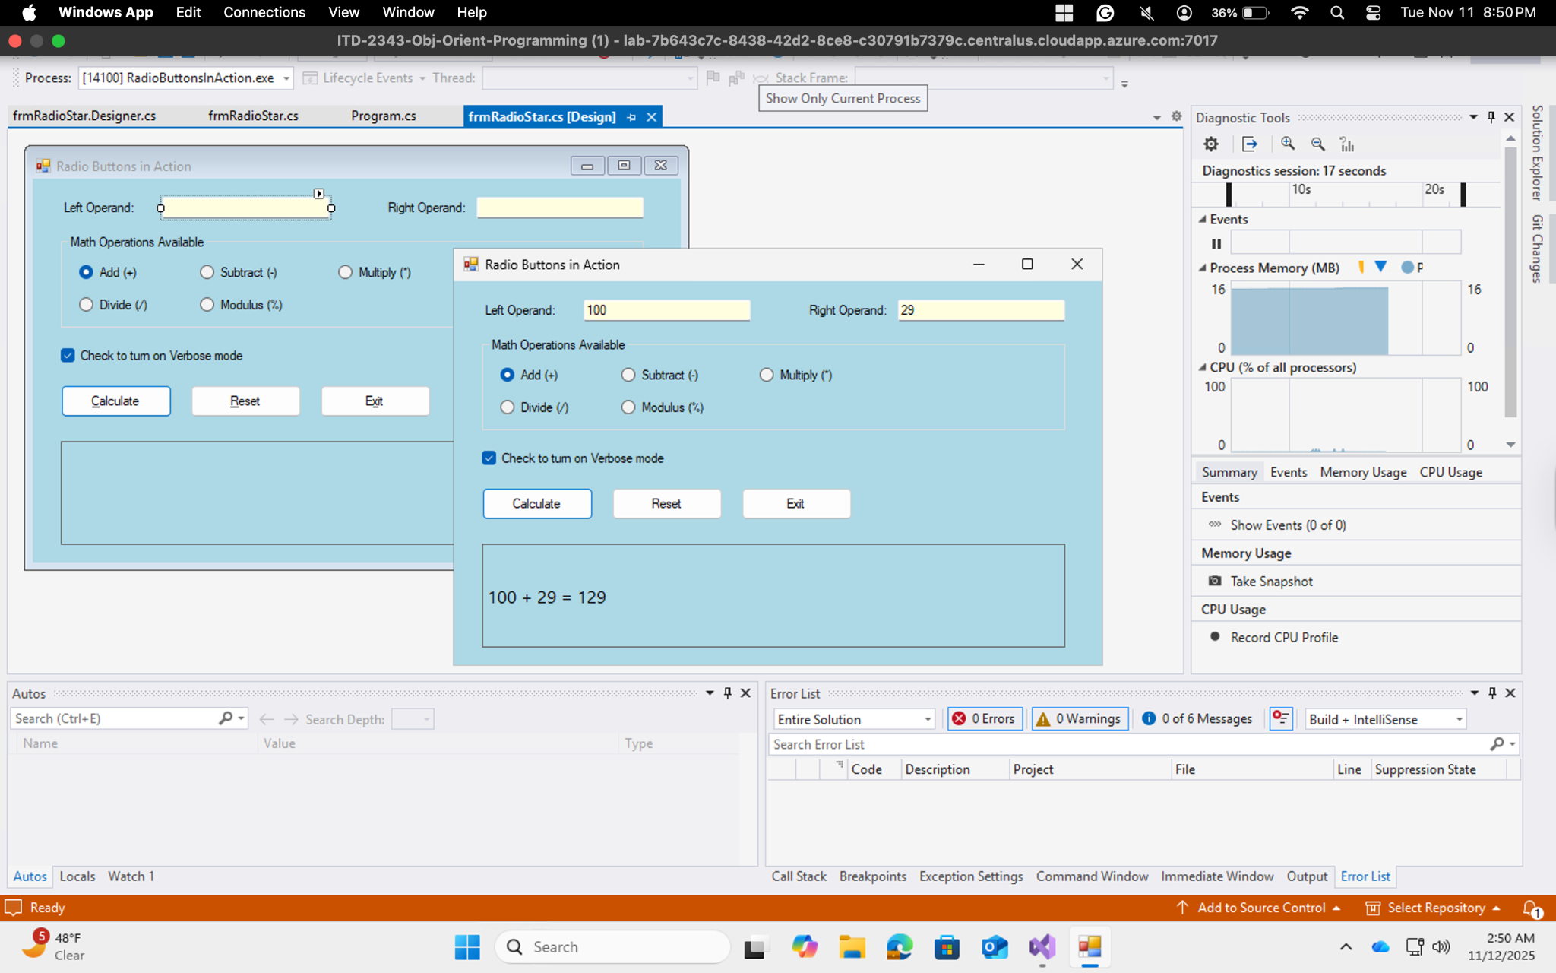

Test Run 2: Subtraction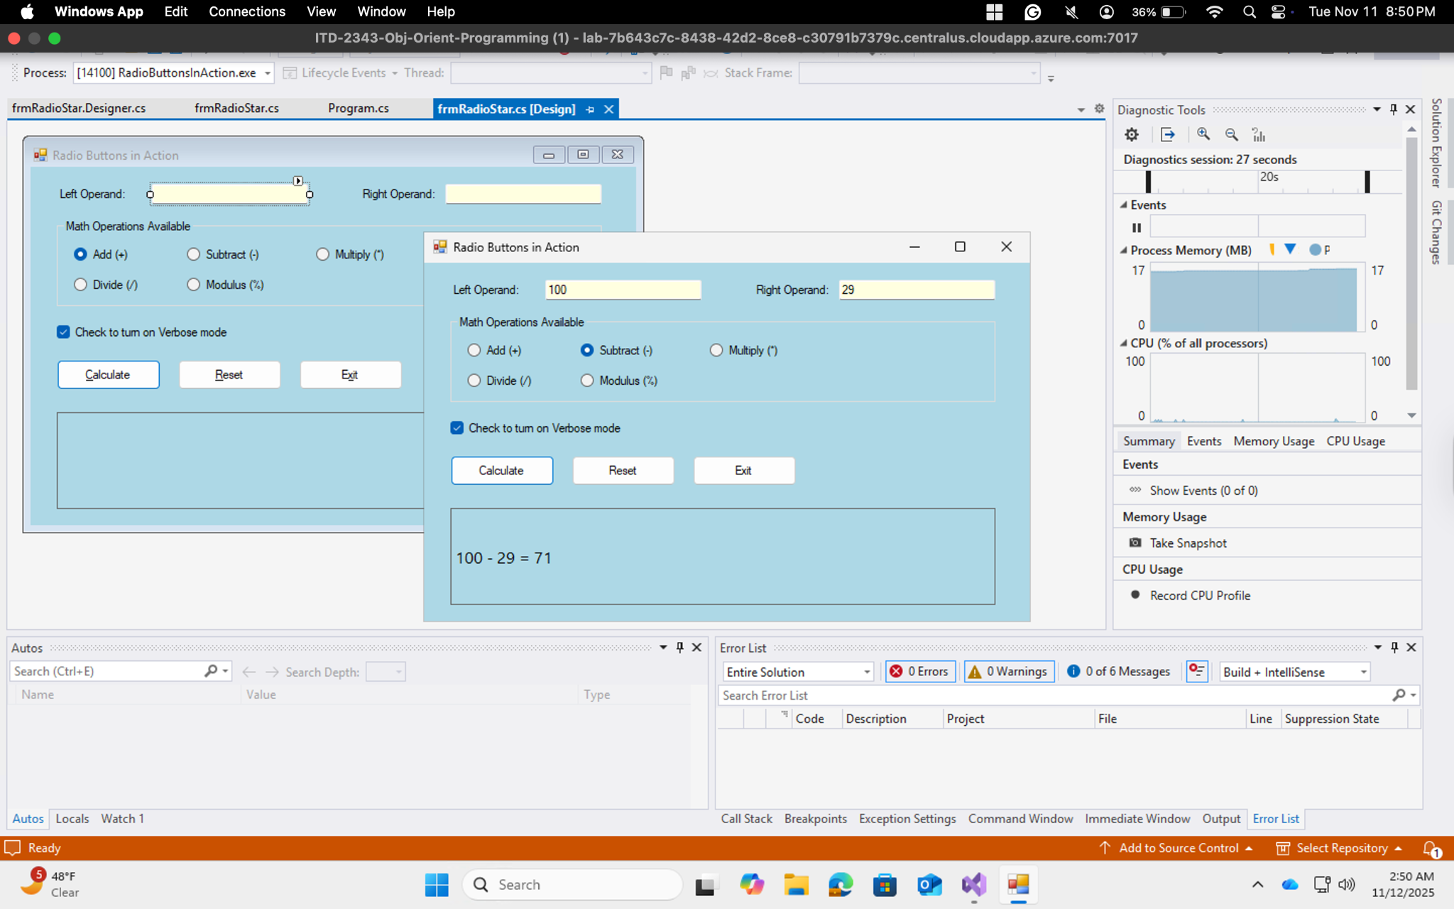

Test Run 3: Multiplication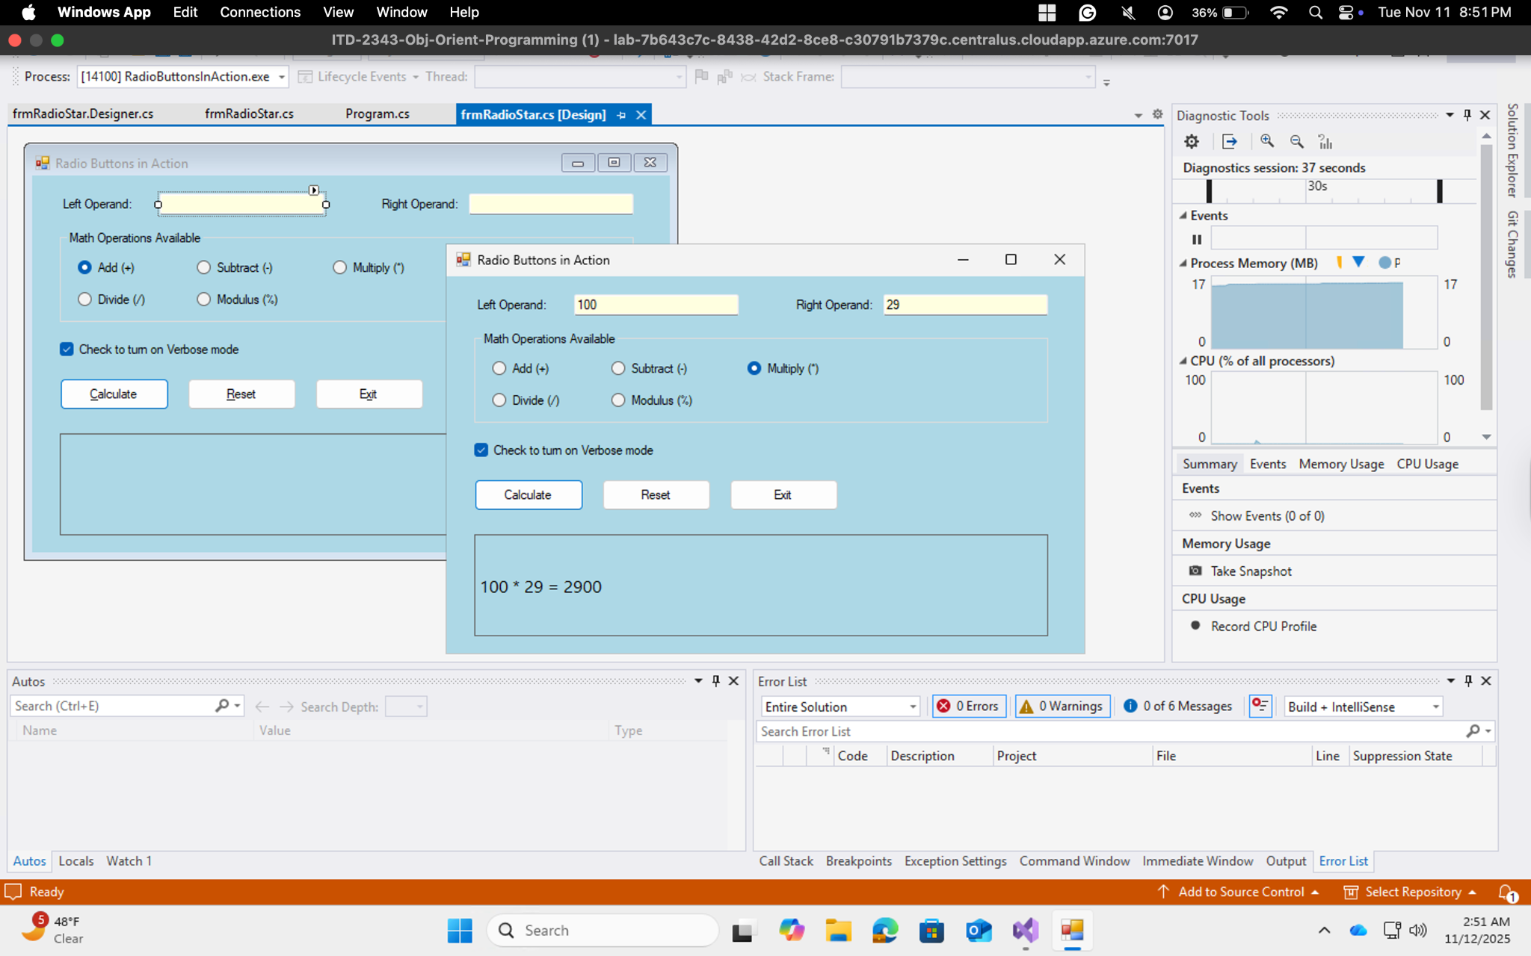

Test Run 4: Division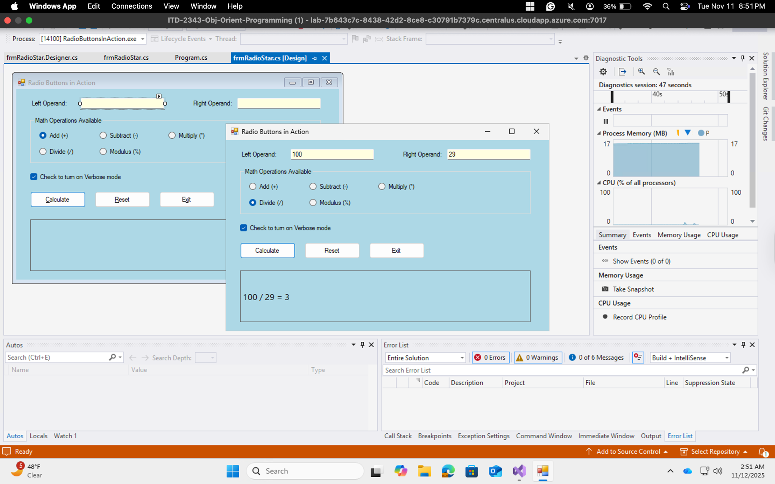

Test Run 5: Modulus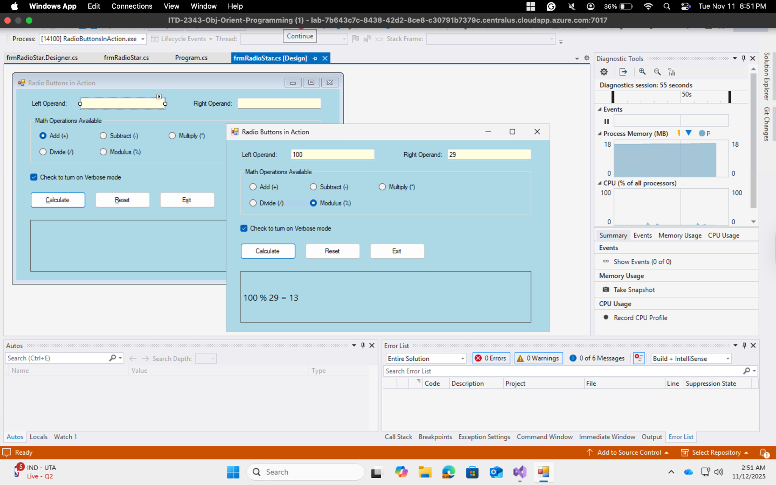

Test Run 6: Addition

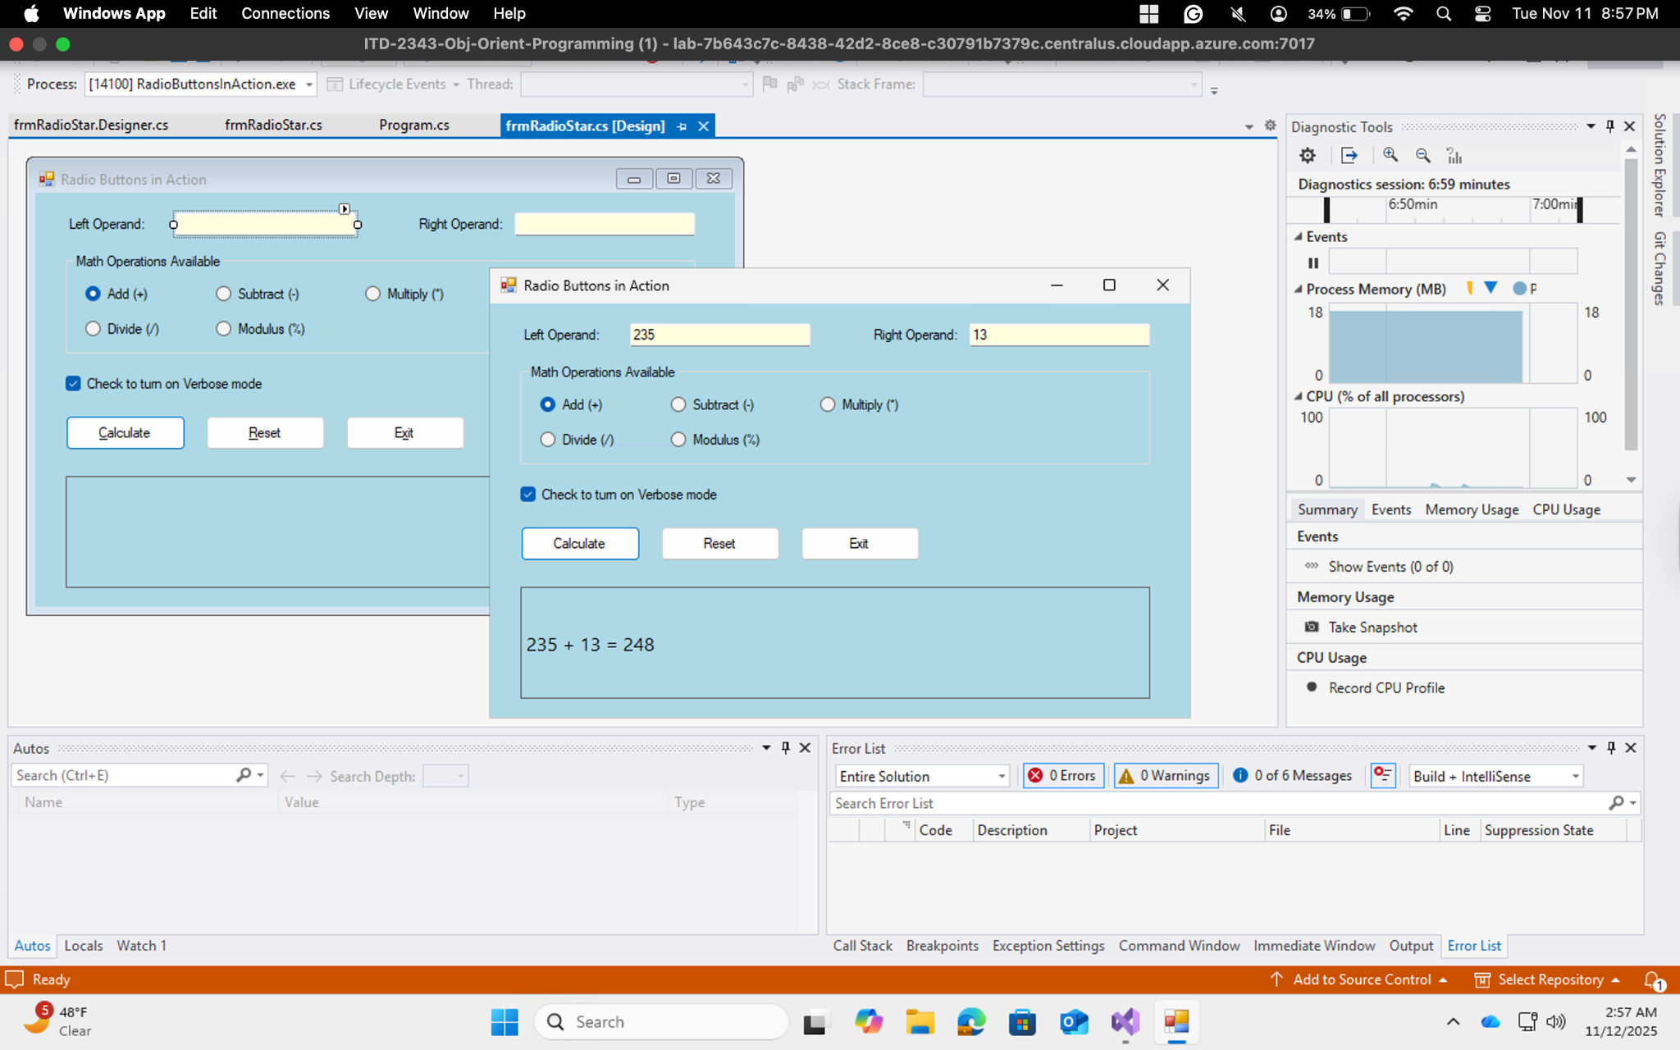

Test Run 7: Subtraction

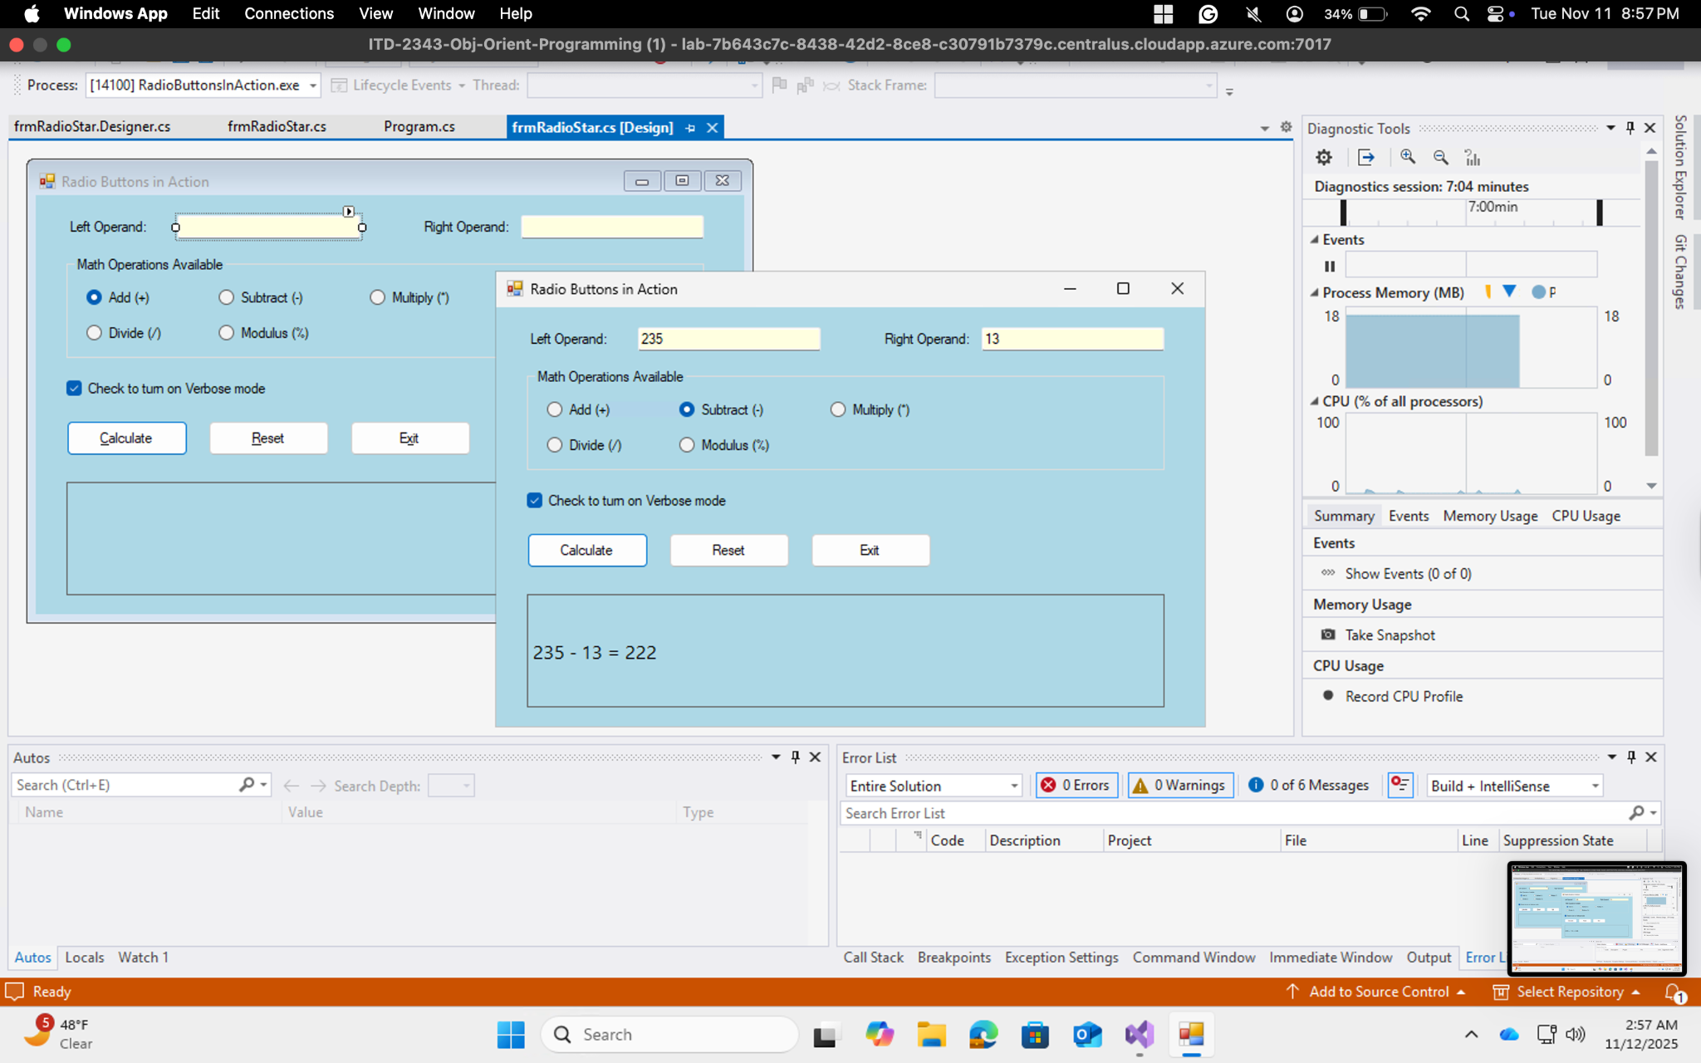

Test Run 8: Multiplication

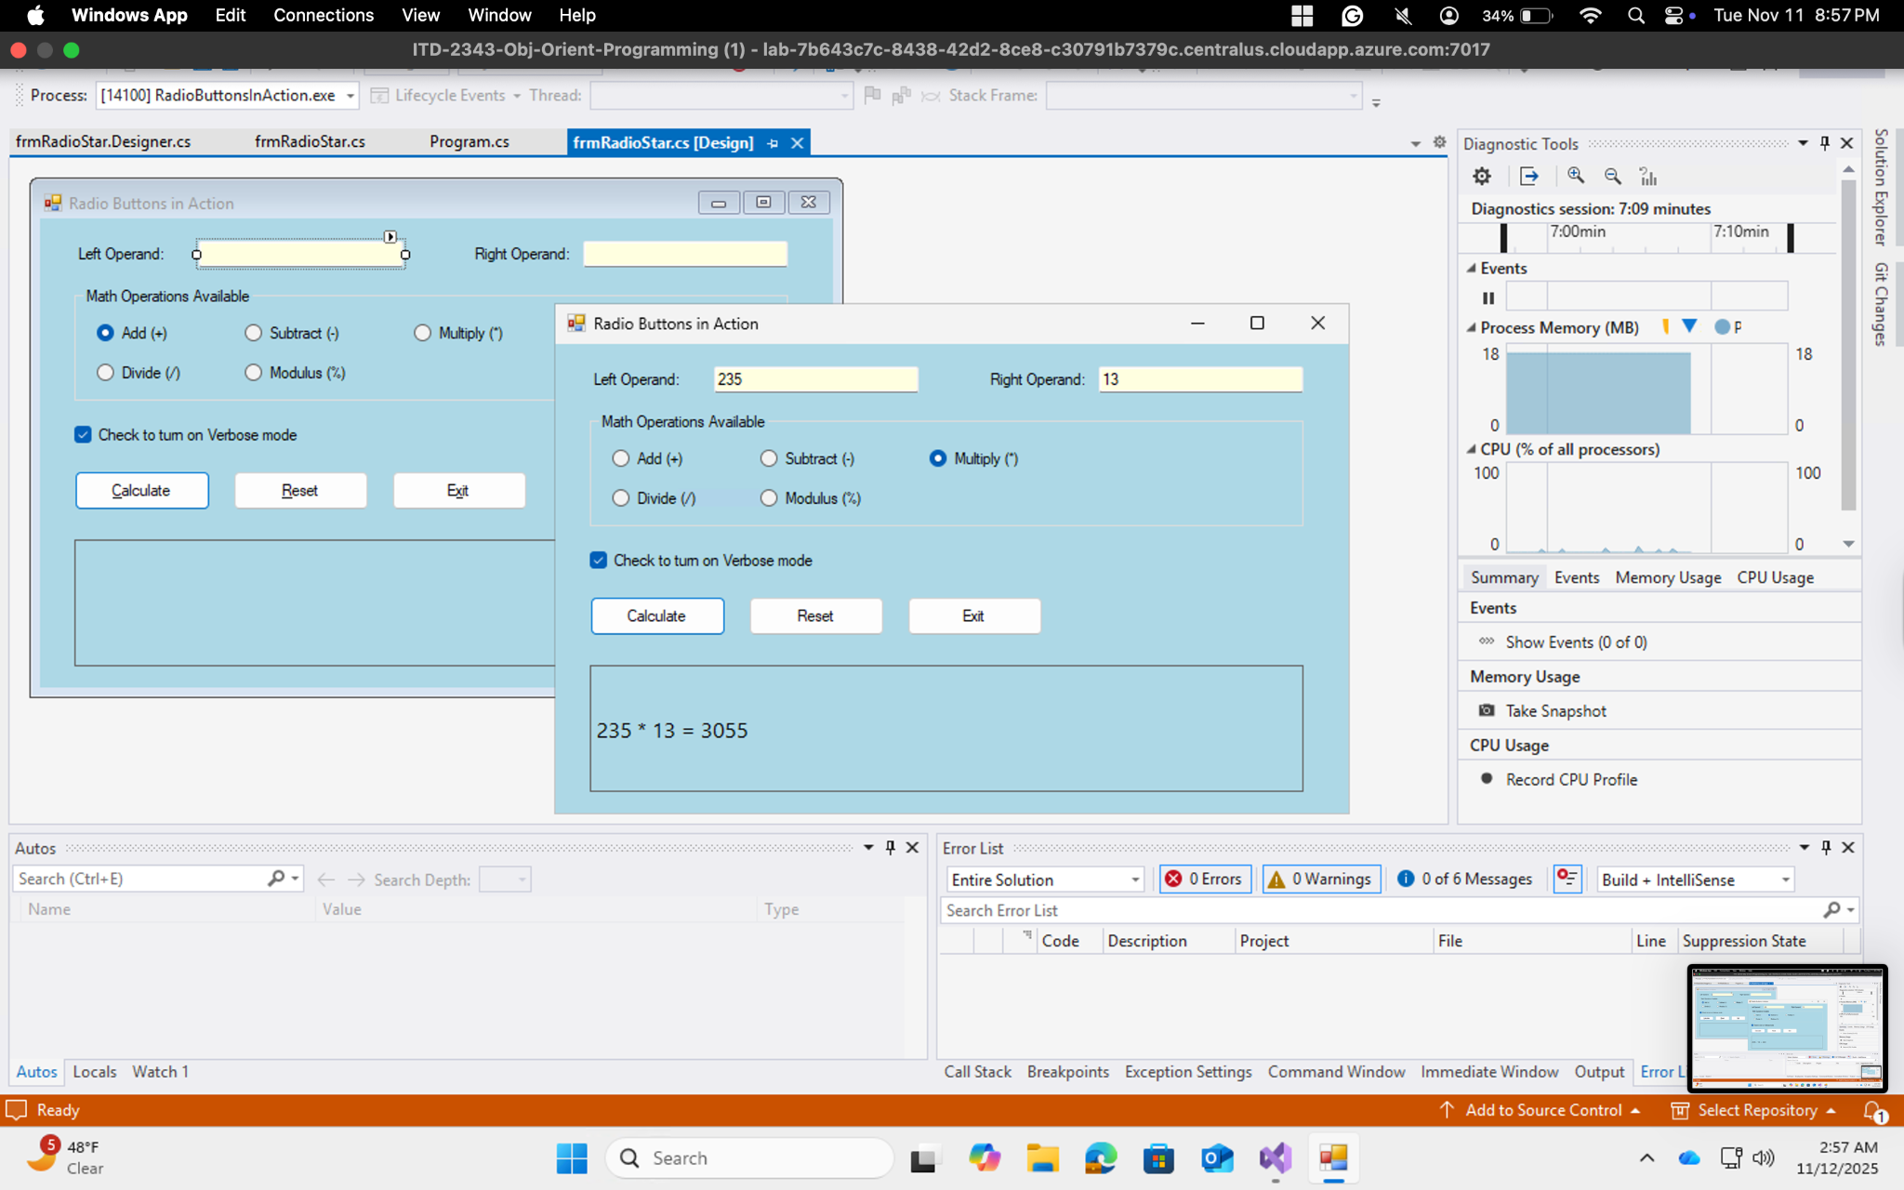

Test Run 9: Division

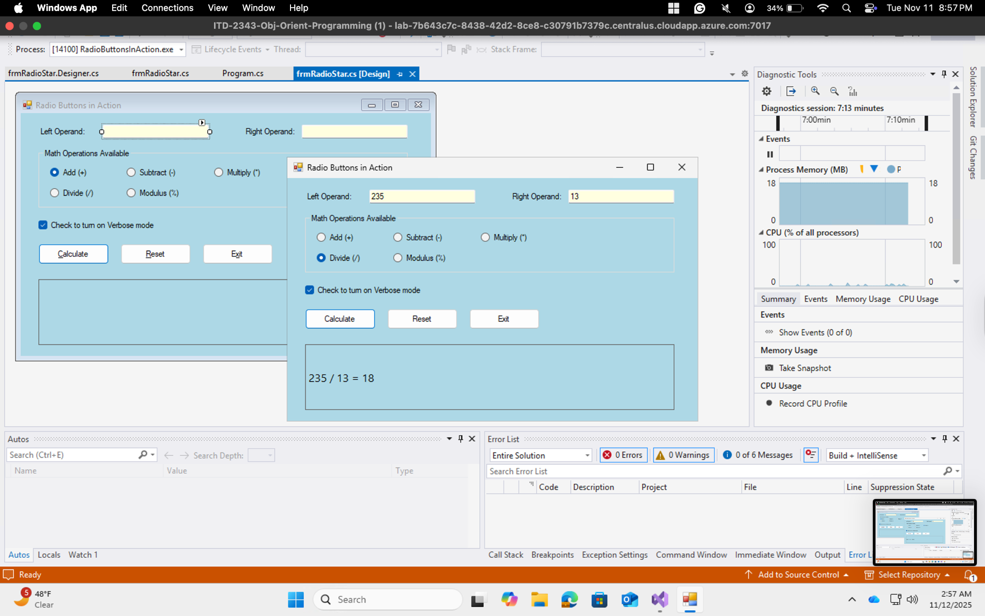

Test Run 10: Modulus

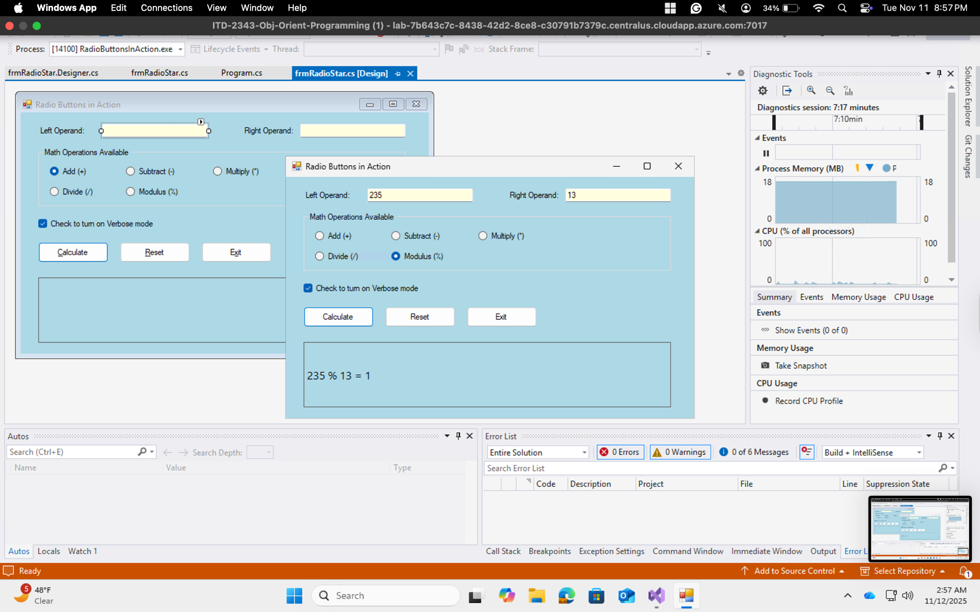

Test Run 11: Error

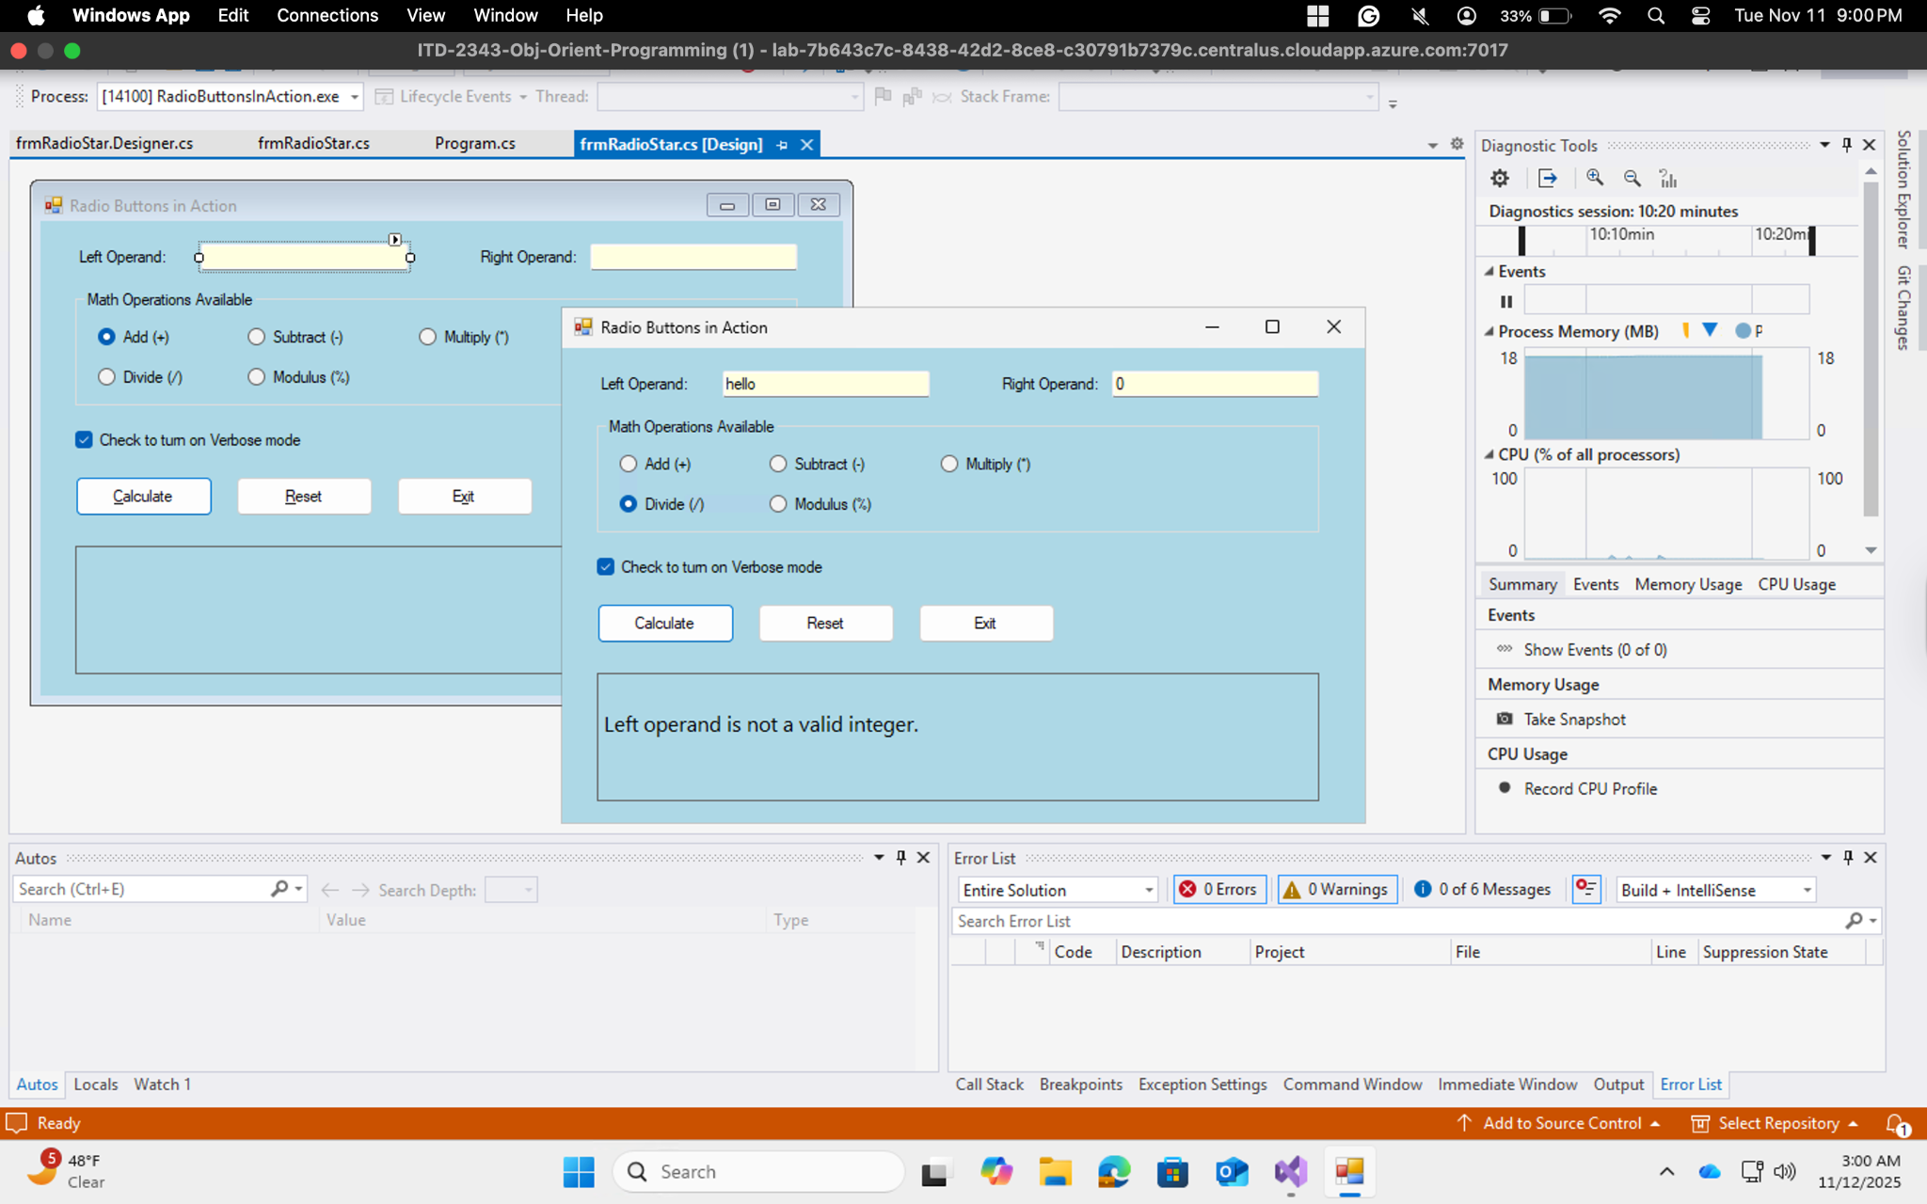

Test Run 11: Both Operands Blank

